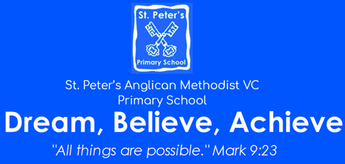 | Terms 1 and 2  Year: 2026 – 2027  EYFS
Personal, Social and Emotional Development  We will learn to recognise different feelings, within ourselves and others, using story characters as a starting point.  We will begin learning to be confident and try new challenges within the classroom and we will learn about resilience and why it is important to persevere.  We will learn about being respectful of different families and homes. We will learn about how to be a good friend. Finally, we will learn about how to keep our bodies safe. | 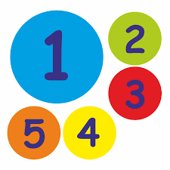  Maths  We will learn to match, sort and compare a range of different everyday items.  We will start developing a secure understanding of numbers to 5 and begin looking at a range of simple shapes. We will apply our knowladge in prevision through adult led activities and challenges.  We will play lots of games and the children will experience maths as part of their normal play inside and outside.
Communication and Language  We will practise taking part in group and whole class discussions, developing the confidence to share ideas and the patience to listen to each other.  Children will be encouraged to ask questions about what they have heard and express their own ideas.  We will have many opportunities to discuss variety of books and use partner talk to make predictions on certain topics or stories. | 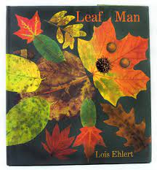  Literacy  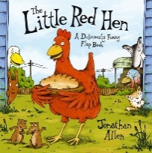  In Drawing Club we will cover a range of stories, traditional tales, animations and more. Drawing Club is an opportunity for children to use their imaginations and create works of art linked to our key text before using their sounds, and numbers, to write a magic code that brings the picture to life.  In Phonics we will be following the ELS scheme as we cover Phase 2 and Phase 3 phonics.
Physical Development  Children will have access to a wide range of fine and gross motor activities designed to support their overall physical development. The outdoor classroom offers a variety of opportunities to develop gross motor skills. In our P.E lessons we will focus on fundamental skills like balancing, running, changing direction, jumping, hopping and travelling. How to stay safe using space, follow rules and instructions and work independently and with a partner. | Understanding the World  This term we will be settling in exploring our new environment, learning about each other. We will talk about our season changing and explore signs of Autumn through various activities. We will celebrate special festivals and learn about important dates related to our history.
Expressive Arts and Design
We will practise mark making and pattern making using a range of mediums and materials. We will experiment with a wide range of tools and materials to create a wide range of art works. Children will have opportunities to create their works of art independently and within adult supported sessions.

