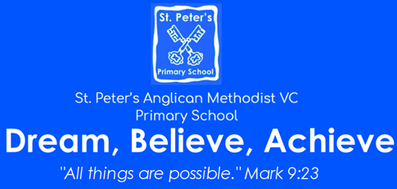 | Cycle: A Terms 1 and 2  Year: 2023 – 2024  KS?  Theme: Stone Age to Iron Age  For Science and History: Please see the knowledge Organisers.
English  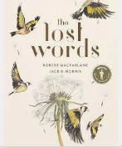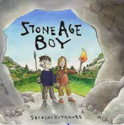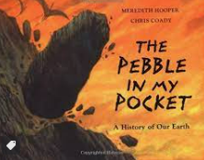  We will look at a variety of text types: poetry, fiction and non-fiction that fit with our topic.  We will create our own poetry, stories and write reports.  We will improve our writing through looking at punctuation, noun phrases, audience and tense.  We will discuss, our books, orally rehearse parts of the text, retrieve answers and infer about the events. | Mathematics  Our main resource will be a place value chart and counters. 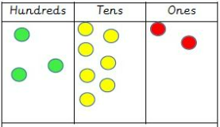  We will make numbers up to 1000, add, subtract and find patterns.  We will compare and order numbers, as well as estimate numbers on a line.  We will revise multiplication and division facts for 2, 5, and 10 before moving onto 4, 8 and 3.  For geometry we will look at the properties of 2D and 3D shapes and types of angles.  Finally, we will look at fractions as equal parts. Then add and subtract them.
Computing including e-safety  Term 1: Computer competency. Logging on, passwords, using a laptop.  Term 2: | PE  Term 1 only: Sums and scrums on a Tuesday morning.  Tuesday afternoon with Bristol sport: Handball then football  Thursday afternoon with Mrs Cannock: Fundamental skills then outdoor and adventurous.
RE:  What is the trinity and why is it important to Christians?  Why are festivals important to religious communities? | Art or DT  Art: The sculpture work of Barbara Hepworth.  DT: Planning and making a sandwich for a party.
Music:
We use the charanga scheme of work to appraise music, find the pulse, use instruments and compose our own music. This is on top of our termly singing square assemblies.
Jigsaw: An opportunity to discuss topics relevant to ourselves and our lives.  Term 1: Being me in my world.  Term 2: Celebrating difference. | Enrichment  Scooter training.

