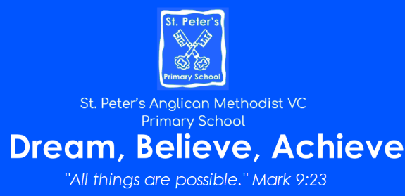
Mathematics Curriculum Policy

School Address | Bank Road  Pilning  South Gloucestershire  BS35 4JG
School Contact Number | 01454 631137

“Mathematics is a creative and highly interconnected discipline that has been developed over centuries, providing the solution to some of history’s most intriguing problems. It is essential to everyday life, critical to science, technology and engineering, and necessary for financial literacy and most forms of employment. A high-quality mathematics education therefore provides a foundation for understanding the world, the ability to reason mathematically, an appreciation of the beauty and power of mathematics, and a sense of enjoyment and curiosity about the subject.”
The National Curriculum 2014
The national curriculum for mathematics aims to ensure that all pupils:
- become fluent in the fundamentals of mathematics, including through varied and frequent practice with increasingly complex problems over time, so that pupils develop conceptual understanding and the ability to recall and apply knowledge rapidly and accurately
- reason mathematically by following a line of enquiry, conjecturing relationships and generalisations, and developing an argument, justification or proof using mathematical language
- can solve problems by applying their mathematics to a variety of routine and non-routine problems with increasing sophistication, including breaking down problems into a series of simpler steps and persevering in seeking solutions

Mathematics at St Peter’s
Mathematics at St Peters is based on the fundamental principle that ‘everyone can achieve’ and therefore no child is left behind and that all children are challenged. The structure of mathematics at St Peters reflects this. Be it with the use of the concrete in the form of manipulative or making pictorial representations to show the ‘real story’ to support and ensure children develop a deeper mathematical understanding. Carefully planned staged learning ensure that children progress quickly and are challenged through a variety of problem solving and reasoning tasks in every lesson.

Pedagogical Principles
Our approach is based on Rosenshine’s Principles of Instruction:

1.Daily Review  2. Present new information in small steps  3. Ask questions  4. Provide models  5. Guide student practise | 6. Check for student understanding  7. Obtain a high success rate  8. Provide scaffolds for difficult tasks  9. Independent practice  10. Weekly and monthly review

The document ‘Pedagogical Principles at St Peter’s in Mathematics’ outlines how these are applied within mathematics lessons at St Peter’s.
Planning
Learning is broken down into small steps to ensure a high success rate within and across a series of lessons. The White Rose and South Gloucestershire small steps planning documents are used to break down learning into small steps. The Calculation Policies outline in detail strategies, methods and resources that are used to aid the learning of the four mathematical operations.

Concrete, Pictorial, Abstract
Our children experience a CPA (Concrete, Pictorial, Abstract) approach in daily lessons. The children begin their learning in the concrete with a range of manipulatives to support their understanding. As their conceptual understanding develops they move towards the pictorial representation of the learning and finally to the abstract numeral and symbols. The children are able to record the ‘real story’ and the ‘maths story’. Children are not pushed to move through these stages until they have shown understanding which the teaching team assess. If the children are secure in their understanding the teaching team will deepen their understanding through reasoning and application of skills or a change of manipulatives. Children will not be accelerated to the next year group’s concepts. The children can access resources from their table’s ‘grab box’ whenever they feel it will benefit their understanding.
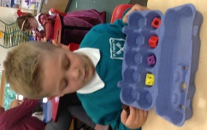
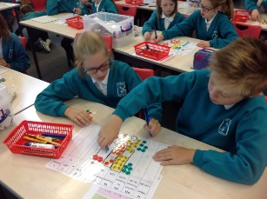
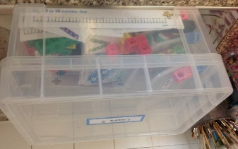

2-2-1 Learning Approach
Where appropriate, such as for the Key Learning Skills, learning will be structured over two days where on the first lesson children will follow the CPA approach and on the second day the focus will be on applying and embedding the concept further through a variety of challenge, problem solving and reasoning tasks.
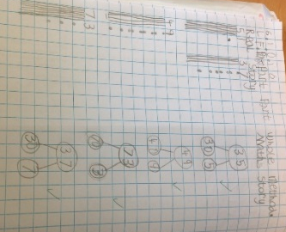
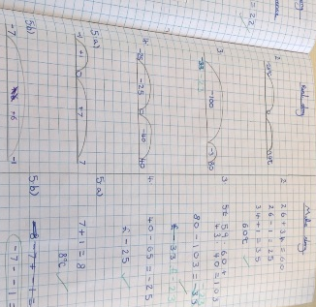
Real Story/ Maths Story
In order to help our children move between and understand the relationship between iconic representations and abstract mathematical symbols, the children record their written maths in a ‘Real Story/ Math Story’ format. This also encourages children to draw pictorial representations to support their conceptual understanding.

Staged Learning Tasks
To ensure that children are secure in their understanding of concepts children will work through progressive stages of learning where they will apply the key concept when solving a variety of problem solving and reasoning tasks. These start with children learning basic concept and children work through ‘stages’ of carefully planned ‘Try It’, ‘Use It’ and ‘Prove It’ tasks which aim to ensure progression and develop a greater depth of understanding and provide challenge.
Whole-class ‘I Do’, ‘We Do’, You Do Approach
During our maths lesson, the whole class benefits teaching small coherent steps in learning through an ‘I Do’, ‘We Do’ and ‘You Do’ approach. With the ‘I Do’ being clear modelling of the process by the learning facilitator, ‘We Do’ being where children are guided through the process and ‘You Do’ where children independently apply the learning. During this time, the children have lots of opportunity to ‘do maths’ independently and in small groups/ partners. The teacher will ‘let the kite out and draw it back in’ regularly to review learning before moving on to the next stage.
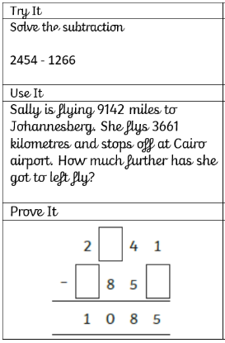
Hinge Questions
Before the children’s independent learning tasks, the children are asked ‘hinge questions’ (or diagnostic questions) as an important check-point in the lesson. These are layered with a ‘Try It’, ‘Use It’ and ‘Prove It’ question. This allows the teaching staff to quickly assess the children’s understanding and progress, and therefore, create ‘support groups’ with teaching staff so that children gain immediate intervention. This also empowers the children to take ownership of their own learning and know their level of understanding.
Same-day interventions
In line with NCETM’s recommendations, the children at St. Peter’s benefit from immediate same-day intervention through the targeted use of AFL such as the ‘Hinge Question’ and targeted questioning and tasks to inform focus groups. This provides children, who have misconceptions or are struggling with a concept, time to work closely with the teacher and essentially ‘catch-up’ before the end of a lesson or series of lessons.
Same Content for all Learners
In line with National Curriculum’s expectation that the ‘majority of pupils will move through the programmes of study at broadly the same pace’, all pupils at St. Peter’s will access the same content in each lesson, unless they are working significantly below age-related expectations. Teaching staff work hard to ensure progression throughout each lesson so that every child has the opportunity to apply and deepen their conceptual understanding. A progression of ‘Prove It’ Reasoning and problem activities extend and stretch their understanding.
Number Talk
In order to develop children’s oracy in mathematics, children will experience daily number talk sessions which aim to ensure that children understand the meaning and confidently use maths vocabulary when reasoning and explain thinking. This will ensure that children can confidently give a verbal explanations which will support them when writing written explanations.
Monitoring and Review
Monitoring of the standards of the pupils’ work and of the quality of teaching in Mathematics is the responsibility of the Senior Leadership and Mathematics Subject Team. The work of the Mathematics Subject Team also involves supporting colleagues in the teaching of Mathematics, being informed about current developments in the subject, and providing strategic lead and direction for the subject in the school. The Mathematics Subject Team creates an annual action plan each year which is reviewed and shared with the Headteacher, governors and staff. The Headteacher allocates management time to the Mathematics Subject Team so that they can review samples of pupils’ work and undertake lesson observations of Mathematics teaching across the school. A named member of the school’s Governing Body is briefed to oversee the teaching of Mathematics.

Appendix of Terms
AFL – Assessment for Learning
NCETM – National Centre for Excellence in the Teaching of Mathematics
Try it – The entry level for a maths task focusing mainly of fluency
Use it – Next maths level that builds on fluency and introduces problem solving elements
Prove it – The highest maths level that incorporates problem solving and reasoning
Pedagogy – a method and practice of teaching a subject. The ‘how we teach maths’ approach.

