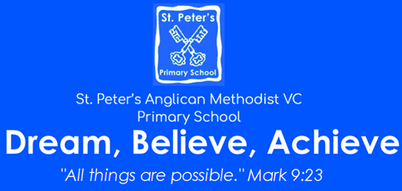 | Cycle: A Terms and 3 and 4  Year: 2023 – 2024  KS1  Theme: ‘I am an adventurer’
English  - We will look at a variety of text types: poetry, fiction and non-fiction that fit with our topic.  - We will continue to write short sentences, building up to writing a longer series of linked sentences and narratives, descriptions, and poems.  - We will look at extending our sentences using conjunctions.  - We will make our writing more interesting with different types of punctuation such as exclamation marks and question marks.  - We will discuss, our books, orally rehearse parts of the text and retrieve answers.  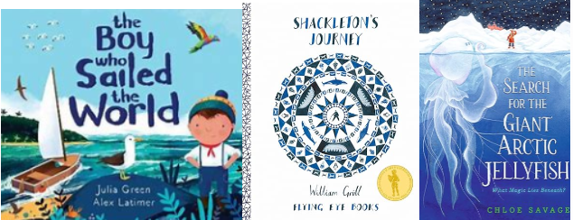 | Mathematics  Year 1: We will start by looking at addition and subtraction within 20. We will focus on  - Adding by counting in and making 10  - Subtraction both crossing and not crossing 10  We will then move on to place value within 50 :  - Counting and recognising numbers to 50  - Comparing numbers to 50  - Counting in 2s and 5s
Year 2: We will start by looking at multiplication and division.
- Using the multiplication symbol
- Counting in 2s 5s and 10s
- Sharing and grouping
We will then move on to Shape and fractions
- 2.D and 3.D shapes and their properties
- Finding and recognising halves, thirds and quarters.
 | Geography  Please see curriculum knowledge organiser on website. | History  Please see curriculum knowledge organiser on website.
Science  Please see curriculum knowledge organiser on website. | Computing including e-safety  Term 3: Creating Media: digital photography  Term 4: Data and information: pictograms | PE  Term 1 with Bristol Sport: Gymnastics  Term 2 with Bristol Sport: Dance  Term 1 with Mrs Bell: Ball skills  Term 2 with Mrs Bell: Sending and receiving
RE  Term 3: Who is a Muslim and what do they believe?  Term 4: Why does Easter matter to Christians? | Art or DT  Drawing: Creating a continuous line drawing in the style of Picasso.  DT: Making Fruit Kebabs | MFL (KS2)
PSHE/RSHE  Jigsaw Term 1: Dreams and goals  Jigsaw Term 2: Healthy me | Music:  We use the charanga scheme of work to appraise music, find the pulse, use instruments and compose our own music. This is on top of our termly singing square assemblies. | Enrichment  Spirituality week  Books at bedtime

