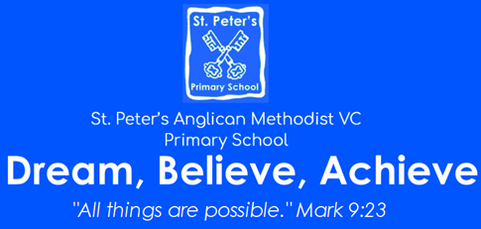 | Cycle: A Terms 3 and 4  Year: 2023 – 2024  KS2  Theme: Ancient Roman Culture  For Science, Geography and History: Please see the knowledge Organisers.
English  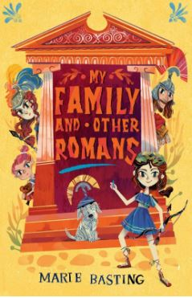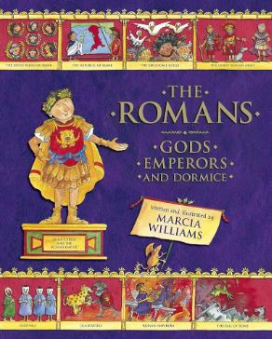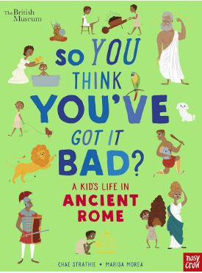  We will look at a variety of text types: poetry, fiction and non-fiction that fit with our topic.  We will create our own poetry, stories and write reports.  We will improve our writing through looking at punctuation, noun phrases, audience and tense.  We will discuss, our books, orally rehearse parts of the text, retrieve answers and infer about the events. | Mathematics  We will continue to look at place value and all four operations (multiplication, division, subtraction and addition)  We will look how to calculate perimeter and area.  We will revise our knowledge of fractions and look at equivalent ones. We will also look at fractions of a number including money.  We will look a Roman numerals in both math and our topic work and see where they are used today.  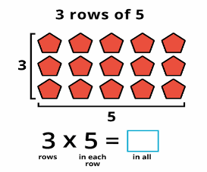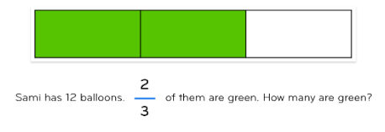  We will continue to use arrays and bar models as our main visual resources.
Computing including e-safety  Terms 3 and 4: Computer competency. Logging on, passwords, using a laptop. Learning word processing skills, completing work and turning it in. Basic programming through scratch programme. | PE  Tuesday afternoon with Bristol sport: Hockey then tennis  Thursday afternoon with Mrs Cannock: Yoga then dodgeball
RE:  Why is prayer important to some people?  Why is Good Friday called this? Easter Studies. | Art or DT  Art: Painting. Looking at the Italian artist Giacomo Balla  DT: Making a sandwich for a picnic
Music:
We use the charanga scheme of work to appraise music, find the pulse, use instruments and compose our own music. This is on top of our termly singing square assemblies.
Jigsaw: An opportunity to discuss topics relevant to ourselves and our lives.  Term 3: Dreams and Goals  Term 4: Healthy Me | Enrichment  Visit to Roman Baths  Roman Wow Day

