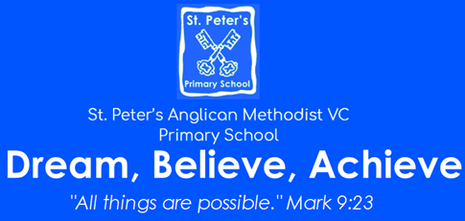 | Cycle: A Terms 5 and 6  Year: 2023 – 2024  LKS2  Theme: Viking and Anglo Saxon Conflict  For Science and History: Please see the knowledge Organisers.
English: Driver Texts (can be changed)  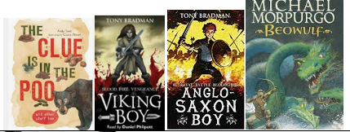  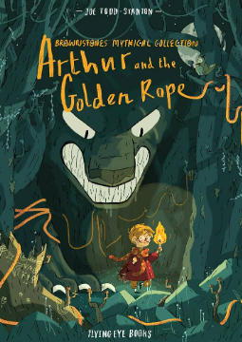  We will look at a variety of text types: poetry, fiction and non-fiction that fit with our topic.  We will create our own poetry, stories and write reports.  We will improve our writing through looking at punctuation, noun phrases, audience and tense.  We will discuss, our books, orally rehearse parts of the text, retrieve answers and infer about the events. | Mathematics  We will continue to look at all 4 operations in a range of problem solving ways.  We will look at measurement: time, volume, and mass. Money will not be a separate topic, but woven throughout our teaching sequence.  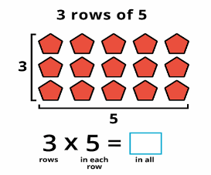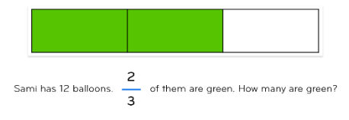  We will continue to use arrays and bar models as our main visual resources.
Computing including e-safety  Terms 5 and 6: Computer competency. Logging on, passwords, using a laptop. Learning word processing skills, completing work and turning it in. Basic programming through scratch programme, research and presentation. | PE  Tuesday afternoon with Bristol sport: Gymnastics then netball  Thursday afternoon with Mrs Cannock: athletics then cricket
RE:  What is the Gospel? What is the Good News  What can we learn from the life of John Wesley? | Art or DT  Art: Drawing: Peter Randall  DT: Making a sandwich for a picnic
Music: Bringing us together (Disco)
We use the charanga scheme of work to appraise music, find the pulse, use instruments and compose our own music. This is on top of our termly singing square assemblies.
Jigsaw: An opportunity to discuss topics relevant to ourselves and our lives.  Term 5: Relationships  Term 6: Changing Me | Enrichment  Viking Wow Day! Thursday 18th April

