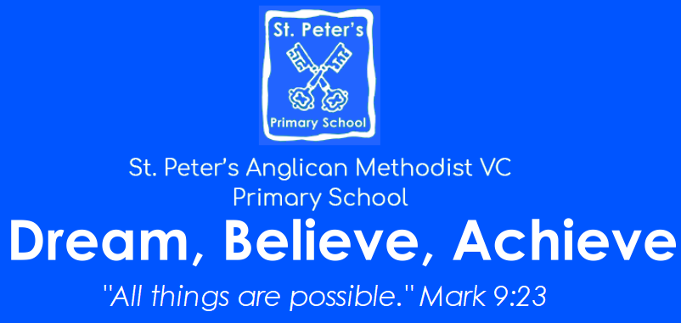
Executive Head Teacher: Mr Paul Smith
Bank Road, Pilning, South Gloucestershire,
BS35 4JG
Tel: (01454) 631 137
Email: office@stpetersprimary.co.uk
Website: www.stpetersprimary.co.uk

21 October 2022
Dear Parents/Carers,
SCHOOL YEAR 2022-2023 – NEWSLETTER NO 4
STARS OF THE WEEK
Congratulations to these children who received the Star of the Week Award from their class teachers over the weeks. They have been working hard and displaying the right attitudes and values of the school, including being Ready, Respectful and Safe. You can also find their picture on the school’s website.
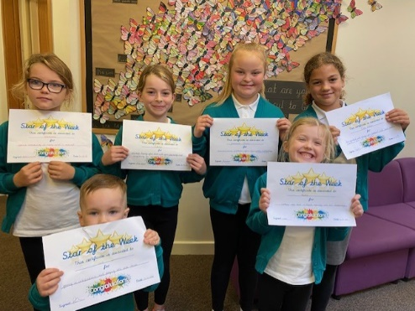
14 October

HARVEST FESTIVAL
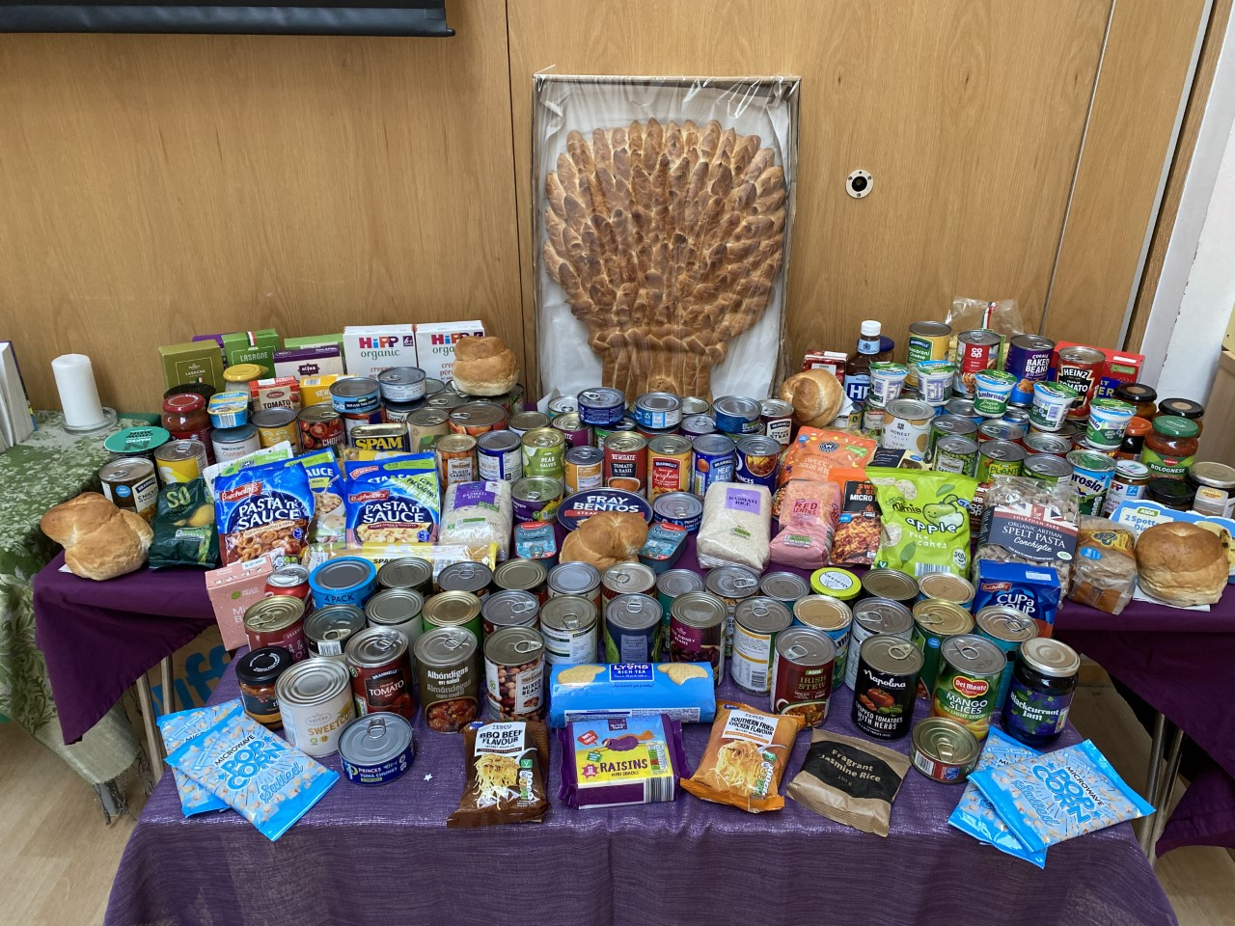It was a lovely Harvest Festival that was held in the hall last week. The children sang brilliantly, as usual, and we were reminded of the toil and hard work that farmers put in to planting, keeping and harvesting the foods that we eat. There was a fantastic display of all the goods that were brought in by the children. The tinned or packet goods that were donated have been taken to the Food Banks namely the local based charity in Yate. Thank you very much for the kind and generous donations. They will be most welcome for the charity. We also had some very tasty bread that was baked and donated by the Downs family for the children. This was shared after the festival, much to the delight of the children.

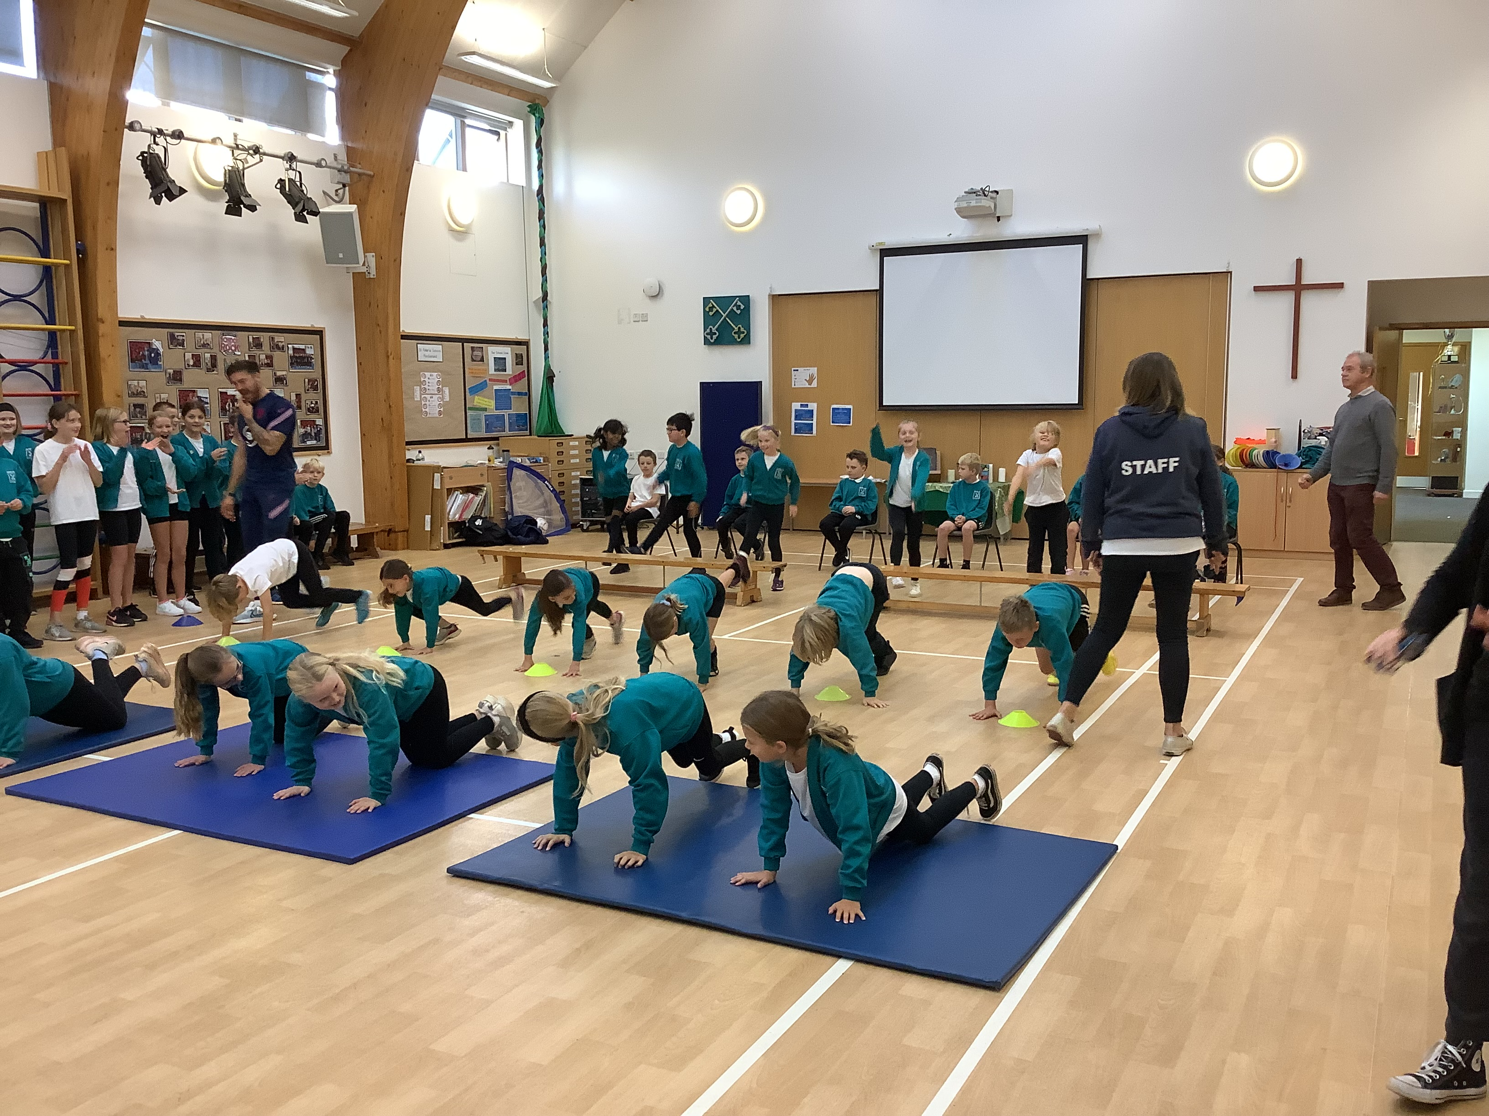SPORTS SPONSORSHIP
Thank you so much for all of your efforts with the sponsorship for the sporting day that we held a couple of weeks ago with Jack Rutter, the Paralympic footballer who visited school. The total raised was an incredible £2,279.85!! This is an extremely impressive amount of money for the school to collect, especially during this times of economic uncertainty. We appreciate and applaud your efforts.

Y6 BIKEABILITY
Congratulations to all our Y6 children who have been awarded a certificate and badge for successfully completing the Bikeability Training Course. Well Done!
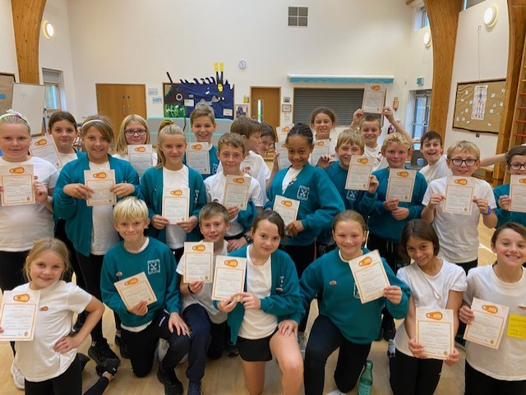

SECOND HAND CHRISTMAS JUMPER DONATIONS & SALE

Donations wanted!
Christmas Jumper Sale
Please leave your outgrown Christmas jumpers in the black FOSP box in the office.
We will then be holding our annual Christmas Jumper sale on Monday 14th November in time for you to buy them before Christmas Jumper Day!

POPPY APPEAL

We are supporting the Poppy Appeal and have products available for the children to purchase during the school day. Zip pull-suggested donation 50p, Reflector-suggested donation 50p, Silicone wrist band-suggested donation £1.00, Snap-band -suggested donation £1.50. There will also be traditional paper poppies available at a suggested donation of at least 20p each. The items will be sold by the Year 6 children at break and lunchtimes on a first come first served basis. If you wish your child to be able to make a purchase please send them into school with their donation, change will not be able to be given. Thank you in advance for supporting the Poppy Appeal.

RECEPTION PARENTS – DROPPING YOUR CHILD OFF IN THE MORNING
As we move into Term 2, we encourage Reception children, when they are dropped off at the gate, to walk into the playground without their parents to build upon their independence. Year 6 buddies will be available to walk with the children as well as older siblings. If you feel your child needs more time, please discuss this with Miss Cox.


CHARLIE FROUD FOUNDATION
This year the School Parliament have decide to support a very local charity, which is based in Almondsbury – The Charlie Froud Foundation. The charity support mountain rescue teams as well as other local charities such as the Jesse May Trust. The children have been set the challenge of collecting as many one penny coins as possible between now and 30 June 2023. We know that at the moment there are some tough choices being made by families so please do not worry if you are unable to give anything between now and then but if you are able to then please do send in your one penny coins. This is also a competition between the other local schools. The school which collects the most coins will receive £1,000 as a reward kindly donated by the Forss family who are trustees. Thank you in advance.

SCHOOL TOURS FOR NEW PARENTS 2023 INTAKE
You may well have seen the banners, which are advertising St Peter’s on your travels recently. We have now confirmed our dates for prospective new parents and children to come and have a look around our wonderful school. These are as follow, please contact the office to book yourself on one of the tours.

Wednesday 2 November 9.00am | Wednesday 2 November 11.00am
Friday 4 November 9.00am | Friday 4 November 11.00am
Tuesday 15 November 1.00pm | Tuesday 15 November 2.00pm


INSET DAY – Monday 31 October 2022
A reminder that school will be closed on the first back after the half term break (31.10.22). School will reopen Tuesday 01 November 2022. Have a lovely break.

Best wishes

Mr Paul D Smith
Executive Head Teacher

LETTERS SENT OUT LAST WEEK AND POSTED ON WEBSITE
CONTENT | YEAR GROUP | INFORMATION OR ACTION

DIARY DATES 2022/23
TERM 2
Monday 31 October INSET DAY – School closed to pupils
Tuesday 1 November Start of term 2 for all pupils
Wednesday 2 November New Parents Tours for intake 2023 9.00am and 11.00am
Friday 4 November New Parents Tours for intake 2023 9.00am and 11.00am
Monday 14 November Second hand Christmas jumper sale after school
Tuesday 15 November New Parents Tours for intake 2023 1.00pm and 2.00pm
Friday 18 November Children in Need day
Monday 21st November Parents evening – face to face session from 3.40 – 6.00pm
Wednesday 23rd November Parents evening – virtual session from 3.40 – 6.00pm
Wednesday 30th November Nasal Flu Vaccines
Thursday 1 December Individual pupil photos
Friday 2nd December FOSP Christmas Fayre
Wednesday 7 December Reception, Year 1 and 2 Christmas performance 6.00pm
Thursday 8 December Reception, Year 1 and 2 Christmas performance 9.30am
Tuesday 13 December Christmas Carols performed by Key Stage 2 (Years 3 to 6) 6.00pm at St Peter’s Church
Wednesday 14 December Christmas lunch for the pupils
Friday 16 December End of Term 2

Term dates for 2022/23
Term | Starts | Ends
Term 1 | Thursday 1 September 2022 | Friday 21 October 2022
Term 2 | Monday 31 October 2022 | Friday 16 December 2022
Term 3 | Tuesday 3 January 2023 | Friday 11 February 2023
Term 4 | Monday 20 February 2023 | Friday 31 March 2023
Term 5 | Monday 17 April 2023 | Friday 26 May 2023
Term 6 | Monday 5 June 2023 | Friday 21 July 2023
INSET DAYS confirmed | Thursday 1 September 2022  Friday 2 September 2022  Monday 31 October 2022  Monday 5 June 2023  Plus one to be confirmed

